|  |  |  |  |  |
| --- | --- | --- | --- | --- |
| Ibest:DNA_SEQ_CORE:Pictures:iBestteeBack9-17.png | The Institute for  Bioinformatics and  Evolutionary Studies | | | Macintosh HD:Users:msettles:Downloads:02UI_Seal-cmyk.jpg |
| **Genomics Resources Core Facility**  **Standard Operating Procedure** | | |
| *TITLE:* | | | | |
| **Dual-Barcoding Two-Step PCR procedure using primers for the ITS region** | | | | |
| *AUTHOR (S):* | | | *REVIEWER (S):* | |
| Suresh Iyer | | |  | |
| *SOP #* | | *REVISION #:* | *DATE:* | *NUMBER OF PAGES:* |
| GRC\_008 | | 1 | February 2013 | 9 |

1. **PURPOSE**

This document describes the method for performing dual-barcoding via a two-step PCR process for amplicons derived using primers for the ITS region. The first PCR step isolates the target specific ITS region whereas the second PCR step adds on Illumina adapters and barcodes. Both PCR primers of the first PCR include universal CS1 and CS2 tags. The second PCR extends the universal sequences with adapters and barcodes for Illumina sequencing. These allow for maximum flexibility in target specific primer usage and the ability to separately barcode or include multiple targets in the same sequencing reaction without needing to purchase a large number of barcoded primers. Barcodes are included in both adapters currently allowing for 16x24 adapters to uniquely identify 384 samples. Fig 1 shows a chart of the procedure.

1. **Background**

Internal Transcribed Spacer (or ITS) refers to a piece of non-functional [RNA](http://en.wikipedia.org/wiki/RNA) situated between structural ribosomal RNAs ([rRNA](http://en.wikipedia.org/wiki/RRNA)) on a common precursor transcript. [Read from 5' to 3'](http://en.wikipedia.org/wiki/Directionality_%28molecular_biology%29), this [polycistronic](http://en.wikipedia.org/wiki/Messenger_RNA#Monocistronic_versus_polycistronic_mRNA) rRNA precursor transcript contains the 5' external transcribed sequence (5' ETS), 18S rRNA, ITS1, 5.8S rRNA, ITS2, 28S rRNA and finally the 3'ETS. During rRNA maturation, ETS and ITS pieces are excised, and as non-functional maturation by-products rapidly degraded. Genes encoding ribosomal RNA and spacers occur in [tandem repeats](http://en.wikipedia.org/wiki/Tandem_repeat) that are thousands of copies long, each separated by regions of non-transcribed DNA termed *intergenic spacer* (IGS) or *non-transcribed spacer* (NTS). Sequence comparison of the ITS region is widely used in [taxonomy](http://en.wikipedia.org/wiki/Taxonomy) and [molecular phylogeny](http://en.wikipedia.org/wiki/Molecular_phylogeny) because it a) is (due to the high copy number of rRNA genes) easy to amplify even from small quantities of DNA, and b) has a high degree of variation even between closely related species. This can be explained by the relatively low evolutionary pressure acting on such non-functional sequences.

**Fig 1.** A flow chart to show the steps involved in the procedure.



**Fig 2.** Primer locations of ITS4 and ITS5

**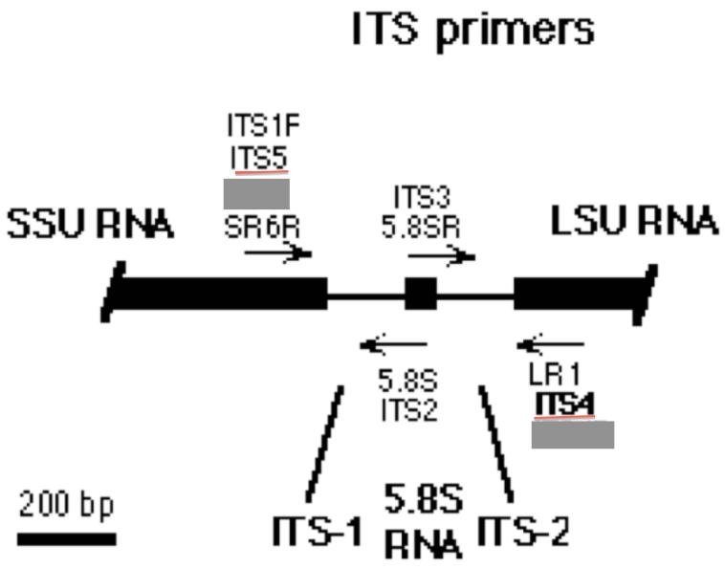**

**Fig 3.** The procedure for the two-step PCR



3. **MATERIALS REQUIRED**

- Agilent Bioanalyzer 2100 (Agilent Technologies, Cat no. G2940CA)

- DNA 1000 Kit (Agilent Technologies #5067-1504)

- PCR grade water, nuclease-free water

- Quant-IT Picogreen dsDNA Assay kit (Invitrogen, Cat# P7589)

-TBS-380 (now QuantiFluor™-ST fluorometer, Promega) or equivalent, or Nanodrop 2000 spectrophotometer (Fisher Scientific #ND-2000)

- 96-well plate reader (Molecular Devices, SPECTRA max GEMINI XPS)

- 96-well plates and adhesive sealing for 96-well plates

- 96-well black plates (Greiner bio-one, FIA-Plate Black 96 well, flat bottom, med binding)

­­-Horizontal gel apparatus (e.g. VWR, Cat no. 89032-290, 89032-288)

-UV transilluminator (e.g. VWR, Cat no. 89131-446)

-Thermocycler (e.g. Applied Biosystems, Cat no. 4314445 and N8050200)

- Ethidium Bromide solution (10mg/ml stock concentration) or GelRed Nucleic Acid Stain (Phenix Research Products, cat#RGB-4103)

- 100bp DNA ladder (Phenix Research Products cat# DNAL-100bp)

- 10x PCR Buffer (NEB cat#B9014S)

- 25mM MgCl2 (NEB cat# B9021S)

- BSA 20mg/ml (Fermentas cat#B14)

- 10mM dNTP mix (Fermentas cat#R0192)

- Taq DNA polymerase 5000U/ml (NEB cat#M0273S)

4. **GENERAL LAB CONSIDERATIONS**

* Work with amplicons must be done on designated bench only, away from laboratory areas where genomic DNA or all other PCR work is generally done.
* Gloves must be worn at all times during the work.
* Work must be done carefully to minimize the risk of aerosols.
* Eating or drinking is prohibited in the lab.

5. **QUALITY CONTROL PROCEDURES**

* Decontaminate all surfaces with 70% ethanol, before and after use.
* Use only pre-packaged aerosol-resistant pipette tips to minimize contamination of pipette shaft.
* Discard the pipette tips after each use to avoid cross-contamination.
* Gloves must be changed frequently, and especially between sample pools, to avoid cross-contamination.
* The pipettes used need to be calibrated annually.

6. **SAFETY CONSIDERATIONS**

* Wear UV protective glasses and gloves during exposure of gels to the UV transilluminator.
* Always have a waste disposable container.
* If ethidium bromide is used to visualize DNA in agarose gels, be aware that ethidium bromide is a potent mutagen. Take proper precaution while handling the solution. Handle only with gloves. Dispose off the ethidium bromide solution properly.
* Make sure to dispose ethidium bromide- containing gels in proper biohazard trash containers.
* Try to use an environmentally safe fluorescent nucleic acid dye, like GelRed Nucleic Acid Gel Stain, to replace the highly toxic Ethidium Bromide to stain DNA in gels.

7. **PROCEDURE**

**A. DNA Quantification**

1. First quantify DNA, preferably using a picogreen assay with a fluorometer or alternatively quantify with a nanodrop.
2. Use 100 ng of DNA for the first PCR step.
3. Use the following PCR set up and cycling protocol for the first PCR:

**NOTE:**

If DNA isolated is in large quantity and the DNA is of good quality, then it is not necessary to use 100ng of template DNA for first PCR. In such cases, ~25ng is enough. On the other hand, if DNA isolated is from difficult samples where you believe PCR could be a problem, then using at least 100ng as template for first PCR is recommended.

**B. PCR conditions for first PCR**

-------------------------------------------------------------------------------------------------------------

Reagents volume final conc.

-------------------------------------------------------------------------------------------------------------

10x PCR Buffer (NEB cat#B9014S) = 5µl 1x

25mM MgCl2 (NEB cat# B9021S) = 6µl 3mM

BSA 20mg/ml (Fermentas cat#B14) = 0.6µl 0.24mg/ml

10mM dNTP mix (Fermentas cat#R0192) = 1µl 200nM

10µM TS-CS1 forward primer = 0.25µl 50nM

10µM TS-CS2 reverse primer = 0.25µl 50nM

Taq DNA polymerase 5000U/ml

(NEB cat#M0273S) = 0.25µl 0.025U/µl

Nuclease-free PCR grade water = 35.65µl

Template DNA = 1.0µl ~100ng/µl

---------------------------------------------------------------------------

Total reaction volume = 50µl

---------------------------------------------------------------------------

95ºC 2 min

-----------------

*20 cycles of*

95ºC 1 min

51ºC 1 min

72ºC 1 min

-----------------

72ºC 10 min

10ºC ∞

**C. 1% agarose gel analysis of PCR products**

5. Run 5µl of the PCR product on a 1% agarose gel. Use ethidium bromide or Gel Red (see Materials section) to stain and view on a UV transilluminator. See Fig 3 for an example gel image. PCR was performed as described above and stained with Gel Red. A 100p DNA size marker was run alongside the samples. A band size at 500bp in the 100bp ladder is shown. The amplicon size should be ~620bp.

**IMPORTANT NOTE***:*

Although for PCR set up BioLabs or Fermentas components were used here, it is possible to obtain similar results with components from other companies. But please be aware that minimal primer dimers need to be present in your PCR product, and this can be accomplished if care is taken to (a) minimize primer concentrations and volumes in the reaction, and (b) always doing a 50µl reaction volume. Obtaining a good PCR and correct size PCR product is critical because otherwise barcodes will not be attached in the next round of PCR.

**Fig 4.**

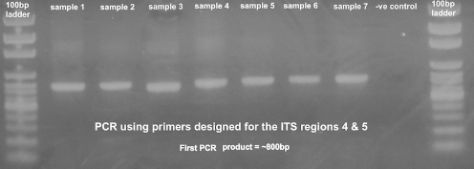

**PAUSE POINT**

After this step the PCR products can be stored at 4ºC for up to 3 days or at -20ºC for longer periods.

**D. Prepare a 50-fold dilution of the PCR products**

6. Prepare a 50-fold dilution of the PCR product from first PCR step, as follows. In a 1.5ml tube add 1µl of product from first PCR step to 49µl of PCR grade water. Vortex well to mix, then centrifuge briefly for 30 seconds to spin down all components.

7. Prepare a reaction mix by combining the following components:

**E. PCR conditions for second PCR**

-------------------------------------------------------------------------------------------------------------

Reagents volume final conc.

-------------------------------------------------------------------------------------------------------------

10x PCR Buffer (NEB cat#B9014S) = 2µl 1x

25mM MgCl2 (NEB cat# B9021S) = 3.6µl 4.5mM

BSA 20mg/ml (Fermentas cat#B14) = 0.6µl 0.24mg/ml

10mM dNTP mix (Fermentas cat#R0192) = 0.4µl 200nM

2µM BC primer = 0.75µl 75nM

Taq DNA polymerase 5000U/ml

(NEB cat#M0273S) = 0.20µl 0.050U/µl

Nuclease-free PCR grade water = 11.45µl

Template DNA = 1.0µl diluted first PCR product

---------------------------------------------------------------------------

Total reaction volume = 20µl

---------------------------------------------------------------------------

95ºC 10 min

-----------------

*10 cycles of*

95ºC 15 sec

51ºC 30 sec

72ºC 1 min

-----------------

72ºC 3 min

10ºC ∞

**F. Quality analysis of PCR products using a Bioanalyzer**

8. Check 1µl of the PCR product on the Agilent Bioanalyzer (BA) using the Agilent DNA 1000 kit. Follow the *Agilent DNA 1000 kit Guide* for details.

**Fig 5.** Typical Bioanalyzer traces after the second PCR are shown below. These BA traces show that when excess concentrations of primers are used large amounts of primer-dimers are present in the PCR product (A, B). A negative control (C) is shown with these high primer concentrations. The peak seen next to the lower marker (at 15bp) is a peak of primer dimers. The optimal primer concentration to use is shown in Fig 4D. It should be noted that use of 75nM or lesser primer concentration in the second PCR reaction would substantially minimize the primer-dimers when compared to 100nM or higher primer concentrations (as seen in Fig 4A-C).

A. B.

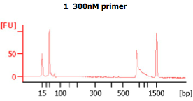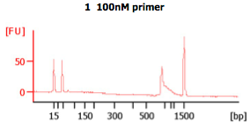

C. D.

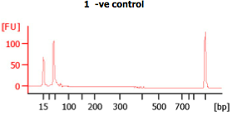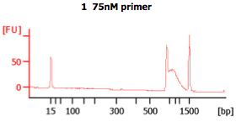

**Fig 6.** Bioanalyzer traces of a sample as well as a negative control (or NTC) after second PCR. The peaks at 15bp and 1,500bp are internal markers. The amplicon peak is shown in A.

**A B**

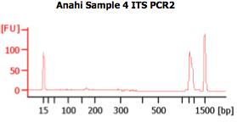 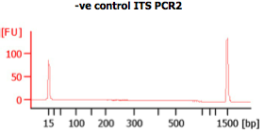

9. Check the results of the chip to determine if the PCR product has the expected size. The PCR products of the barcoding stet (second PCR step) should exhibit a band shift of ~69bp when compared to first step PCR products.

10. Store the PCR products at -20ºC.

**G. DNA quantification**

11. Quantify final PCR products with a Fluorometer using the picogreen assay.

12. Provide the IBEST GRC laboratory with the following:

* 100 ng of each amplicon product
* A high-resolution gel image from first PCR, and Bioanalyzer traces from second PCR. Please do not provide us laser printed images. Digital Images are best.
* Please see and follow the sample submission instructions and fully complete the sample submission sheet, both provided on our web site (<http://cores.ibest.uidaho.edu>)